

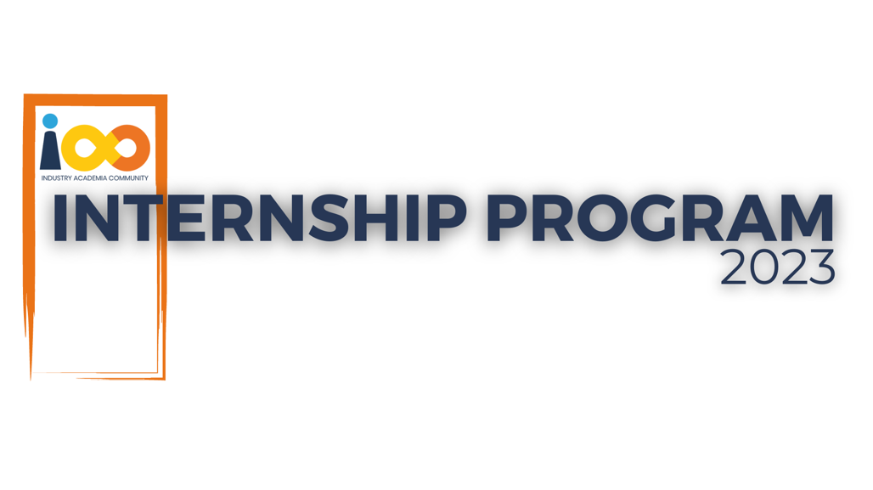

PROJECT REPORT

Java  
  
IAC Community Ambassador Onboarding Process

|  |  |  |  |
| --- | --- | --- | --- |
| **Created By:** | Rashmi Sahani | **Approved By:** |  |
| **Created On:** | 31 – 05 - 2025 | **Approved On:** |  |

Page left blank intentionally

**INDEX**

**1** **PROJECT DETAILS** 2

**2** **SUMMARY** 2

**3** **INTRODUCTION** 2

3.1 Background 2

3.2 Stakeholders 2

3.3 Objectives 2

**4** **METHODOLOGY** 2

4.1 Considerations & Assumption 3

4.2 Approach 3

4.3 Activities 3

**5** **TARGETTED V/S ACHIEVED OUTPUT** 3

**6** **CONCLUSION** 3

**7** **APPENDICES** 4

7.1 Appendix A – Title 4

**General Instructions for using the Live Project Report Template**

* This template and the subsequent document created using this template is a confidential document and is the intellectual property of Cloud Counselage Pvt. Ltd. Circulating it outside of the organisation without the consent of Cloud Counselage Pvt. Ltd. is the breach of company policies and will lead to legal actions
* This template is a guideline document to communicate the implementation of design ideas and the results of the work to the stakeholders.
* The **text between inequality (< >) is to be replaced** by relevant text
* Please **remove the yellow highlight on the Text** between the inequality (< >). This is done to help you notice the text to be changed/replaced
* The text in *italics* highlighted in grey is just for reference and should be removed after adding the relevant text

# **PROJECT DETAILS**

|  |  |  |  |
| --- | --- | --- | --- |
| **Project Name** | IAC Community Ambassador Onboarding System | | |
| **Project Sponsor** | Cloud Counselage Pvt. Ltd. | | |
| **Project Manager** | Harshada Topale | | |
| **Start Date** | 27-002-2025 | **Completion Date** | 31-005-2001 |

# **SUMMARY**

The *IAC Community Ambassador Onboarding System* project aimed to simplify and automate the onboarding process for student ambassadors joining the Industry Academia Community (IAC). The key goal was to generate unique UTM tracking links automatically and send them via email as part of a personalized welcome message. This helped the organization track ambassador performance, link generation, and outreach efforts more efficiently.

The project was necessary to reduce the manual workload of onboarding and to build a performance dashboard based on real-time data. It brings value by saving time, reducing errors, and improving the tracking and evaluation of ambassador activities. In the long run, this system helps IAC scale up its ambassador program more smoothly and maintain accurate records with minimal human effort.

# **METHODOLOGY**

These conventions are all about the positions of line breaks, how many characters should go on a line, and everything in between.

## Considerations & Assumption

Since the internship was remote and self-paced, I assumed sole responsibility for all development tasks. A key constraint was time — the project required a minimum of 240 hours and needed to be completed alongside academic responsibilities. I assumed MySQL and JavaMail would be supported on the local machine. Internet access for SMTP setup (Gmail) was also assumed. The system was designed keeping scalability and simplicity in mind, assuming single-user handling at a time during MVP stage.

## Approach

I followed a waterfall-based approach as recommended by the program guidelines. This structure allowed me to move step-by-step — starting from requirement gathering, followed by system design, coding, testing, and final deployment. For each phase, I documented progress, received regular feedback, and updated the solution iteratively. I also used GitHub for version control and MySQL for persistent data storage.

## Activities

* Gathered and understood requirements from the problem statement document.
* Created a project charter and broke the tasks down using WBS (Work Breakdown Structure).
* Designed database schema and system architecture using UML-like visuals.
* Built core features using Java — UTM generator, DB integration, email sending.
* Added extra features like CSV export, update/delete/search modules.
* Conducted local testing of all modules and documented test cases in a Test Plan.
* Created final deliverables — demo video, project code (zipped), reports, logs, etc.

# **TARGETTED V/S ACHIEVED OUTPUT**

The goal was to build a Java-based system that automates the CA (Community Ambassador) onboarding process by generating UTM links, saving ambassador data to a MySQL database, sending a welcome email with the UTM, and optionally exporting or displaying ambassador data.

**Achieved Output:**  
I successfully built the core application using Java, JDBC, and JavaMail. The system:

* Generates personalized UTM links
* Stores ambassador data in a MySQL DB
* Sends simulated and real welcome emails via JavaMail
* Includes bonus features like CSV export, view/search/update/delete ambassador data
* Captures all functional, testing, and project artifacts as per the deliverables list

**Deviation:**

* Real email via JavaMail took longer to configure due to Gmail SMTP and App Password restrictions, but was eventually resolved.
* A GUI was not built since the project was scoped as a console-based application, and focus remained on logic, data flow, and automation.
* DevOps or deployment on a server/cloud was not done due to optional nature.

Overall, the project met all critical objectives within the required timeline and hours.

# **CONCLUSION**

This project adds real value to IAC by streamlining the ambassador onboarding process. It minimizes manual work, enables performance tracking via UTM links, and ensures timely communication through automated emails. For stakeholders, it brings visibility, structure, and efficiency into the CA enrolment journey.

**Future Scope:**

* Add web-based UI using Spring Boot or JSP/Servlets
* Deploy to cloud using AWS or Firebase
* Add analytics dashboard for UTM performance
* Enable multi-user authentication and admin portal for performance review

This project helped me sharpen my backend development skills, understand real-world use cases, and experience working end-to-end on a system — from planning to deployment.

# **APPENDICES**

## Appendix A – Title

|  |  |  |
| --- | --- | --- |
| **Component Name** | **Type** | **Purpose** |
| CommunityAmbassadorApp | Java Class | Main class that handles user interaction, UTM link generation, DB operations |
| MySQL Database | Database | Stores ambassador records including name, email, college, and UTM link |
| JavaMail API | Library/API | Used to send automated welcome emails to new ambassadors |
| ambassadors Table | DB Table | Stores ambassador data (id, name, email, college, utm_link) |
| CSV Export Function | Utility Method | Allows admin to export ambassador data into CSV for offline reporting |
| viewAmbassadors() | Java Method | Displays list of registered ambassadors from the database |
| JDBC Connector (MySQL) | Library/API | Facilitates communication between Java app and MySQL database |